

Specification

for

SQLdm Import Wizard

Shekhar Vaidya



Proprietary and Confidential to BBS Technologies, Inc.

© 2006 BBS Technologies, Inc.; all rights reserved.

Revision history:
When? | Who? | What?
12/28/06 | Shekhar Vaidya | First draft – functional requirements
1/5/07 | Shekhar Vaidya | Incorporated first draft comments.
1/12/07 | Shekhar Vaidya | Merged with import settings spec.
1/16/07 | Shekhar Vaidya | Added screen shots
1/17/07 | Shekhar Vaidya | Sent for core team review
1/22/07 | Shekhar Vaidya | Incorporated Rodney/Trent comments
1/24/07 | Shekhar Vaidya | Incorporated Heather/John comments

Table of Contents
1. Revision history: ii
2. Table of Contents iii
3. Requirements 1
3.1. Overview/Purpose 1
3.2. Target Users 1
3.3. Features 1
3.3.1. Required Features 1
3.3.2. Non-Supported Features 3
3.4. FAQ 3
3.5. Open Issues 3
4. Functional Design 4
4.1. User Interfaces 4
4.1.1. Launching the Import Wizard 4
4.1.2. Connecting to the Repository 4
4.1.3. Welcome Page 5
4.1.4. Import Option Selection 5
4.1.5. Import servers and settings 6
4.1.6. Import historical data 9
4.1.7. General User Interface Considerations 11
4.1.8. Help Integration 12
4.2. Installation and Upgrade 12
4.3. Permissions and other Required Configuration 12
4.4. Licensing Issues 12
4.5. Dependencies 12
4.5.1. Dependencies on Idera Software 12
4.5.2. Third-Party Software Required on the Customer Machine 13
4.5.3. Third-Party Software Required Internally 13
5. Technical Design 13
5.1. Architecture 13
5.1.1. Settings Import 13
5.1.2. Data Import 24
5.2. Installation Issues 24
5.3. Schedule 25
5.3.1. Work Breakdown and Sizings 25
5.3.2. Areas of Risk 26
6. Quality Assurance Considerations 26
6.1.1. Overview 26
7. Documentation Considerations 27
8. Bibliography 27

Requirements

Overview/Purpose
This specification details the import of settings and data from earlier versions of DM to DM 5.0.
Note: Details about importing data has been added to the previously reviewed version of this specification. The older version had focused on importing settings.

Target Users
This wizard is targeted towards customers who are upgrading from an older version of DM to DM 5.0.

Features

Required Features

Import wizard
The import utility is a wizard, called DM 5.0 Import Wizard. The Import Wizard can be launched from the Desktop Client or from the Start Menu. The Import Wizard is always installed with the Desktop Client.

Supported versions – DM 4.x
The Import Wizard will only support importing of settings and data from DM 4.0 and higher.

Import from multiple DM installations
Settings and data from multiple DM installations can be imported to a single DM 5.0 Repository. This will allow customers to consolidate multiple DM installations to a single DM 5.0 installation.

Settings import
- Import the list of servers to monitor, including connection settings.
- Allow user to select which servers to import.
  - Note 1- Only settings for servers not registered in DM 5.0 can be imported.
- Import alert thresholds.
- Import notification settings for sending emails (i.e. recipients) and writing to the application event log (i.e. computer names).
- Import SMTP provider settings.
- Import the “maintenance mode” setting of each monitored server.
- Import the statistics collection settings.
- Import the Query Monitor Trace settings.

Data import
- Only the data stored in historical data files will be imported. The import of DM 4.x Metrics Repository data is not supported.
- The server, for which data will be imported, has to be registered in DM 5.0. This means that the customer has to register the server in DM 5.0, before importing data.
  - Note 1 - The server does not have to be actively monitored at the time of import.
  - Note 2 - The workflow for importing settings has been updated to allow a customer to import data after settings have been imported.
  - Note 3 – When just importing data using the wizard, the server has to be registered in DM 5.0.
- Only data older than the time that a server was registered in DM 5.0 can be imported. This restriction has been placed to avoid interlacing of data from different DM versions. For example, if a server was registered in DM 5.0 at 13:00:00 01/12/07, then only data older then this registration time can be imported.
- The customer can specify data from “how far back” to import. The data from the timestamp a server was registered with DM 5.0 to the past date specified by the user will be imported. DM 5.0 will remember the date to which data has been imported for a server. If the date specified is after the currently imported date, then no data will be imported. If the date specified is before the currently imported date, then data will be imported from the current date to the new date.
- The data that is imported by the wizard is listed below. Note: Alerts and To-do list are not supported.
  - Server statistics
  - OS metrics
  - Database statistics,
  - Database growth statistics
  - Table growth statistics
  - Worst performing queries
- The customer cannot select a sub-set of data to import. All data, supported by the wizard, will be imported for the selected server.

Log import activity
The import of data and settings will be logged to a diagnostic log for troubleshooting. Tech Support has found that importing of historical data can be error prone, and logging all import activity will help in diagnosing customer issues.

Non-Supported Features

Remote import
The migration of DM 4.x data from remote boxes is not supported. The DM 5.0 Migration Tool will have to be installed on the DM 4.x box to migrate data to DM 5.0.

Settings import restrictions
- The following notifications will not be imported since they are not supported in Project Houston:
  - Beep
  - Call a program
  - Send a network message
  - ODBC
- Settings that are specific to a form or client, such as form sizes, refresh rates, and display filters, will not be imported.
- Settings related to grooming (e.g. deletion of old alerts) will not be imported.

Data import restrictions
- The server has to be registered with DM 5.0 to import its DM 4.x data.
- Import of data from DM versions older then DM 4.x will not be supported.
- DM 4.x data cannot be imported for any time after a server has been registered with DM 5.0.
- Import of DM 4.x Metrics Repository data to DM 5.0 Repository will not be supported.
- Alerts and To-do list data will not be imported.

FAQ

Open Issues
None.

Functional Design

User Interfaces

Launching the Import Wizard
The Import Wizard will be installed when the Desktop Client is installed. It can be launched from the Desktop Client or from the Start menu.
In the Desktop Client, the Import Wizard can be launched from:
- “Welcome to Idera SQL diagnostic manager” page – this is the page that comes up when there are no monitored SQL Servers. This page has an option to “Add new servers” and “Import settings and data”.
  - Note: The currently implemented screen in the Desktop Client has data and settings as separate options. They will be combined to be a single import settings/data option.
- Tools->Import Wizard
In the Start Menu it can be launched from:
- Idera->SQL diagnostic manger 5.0->Tools->Import Wizard
If there is no older version installed, or the older version is not 4.0 or higher the following errors displayed are shown below. The Import Wizard ends when the user clicks OK.
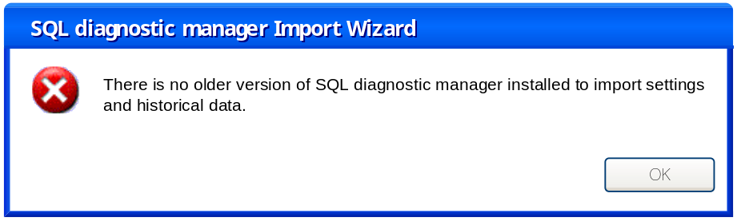
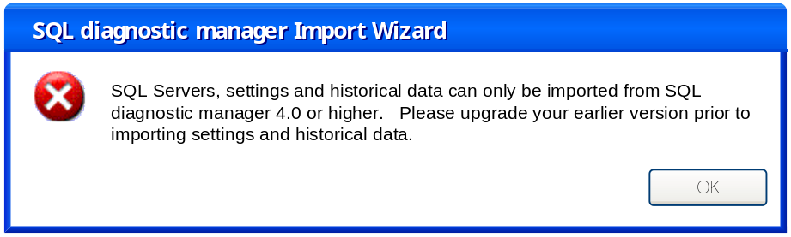

Connecting to the Repository
The customer can specify the SQLdm Repository to connect to using the dialog shown below. If the Import Wizard is launched from the Desktop Client, the fields will be pre-filled with the connection information used by the Desktop Client.
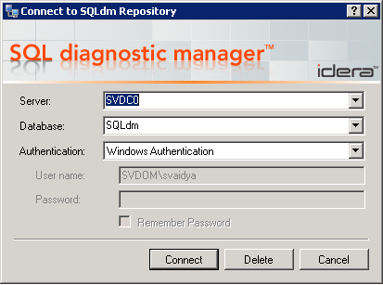

Welcome Page
The welcome page of the Import Wizard is shown below.
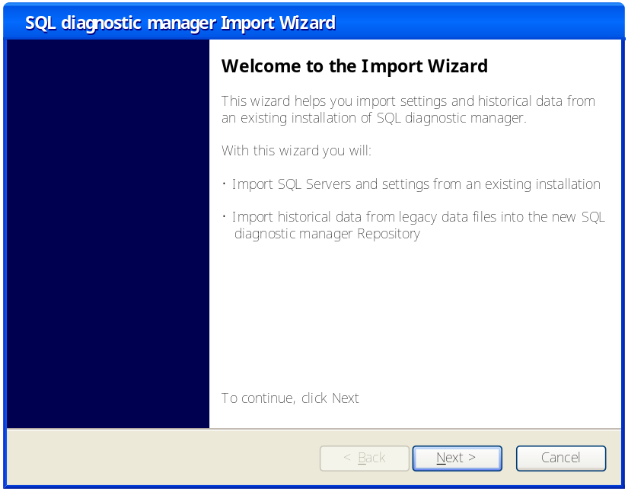

Import Option Selection
The customer can select either importing settings or historical data. The Next button will take them to the appropriate page depending on the selected option.
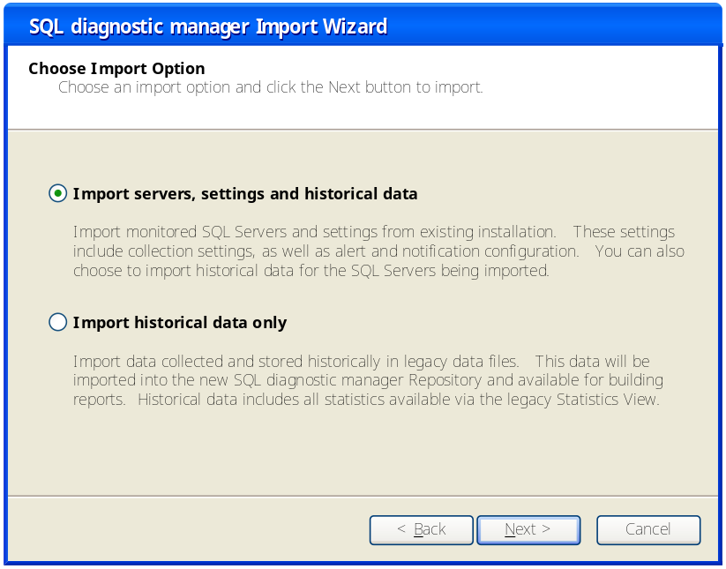

Import servers and settings

Select SQL Servers
The “Select SQL Servers” page is displayed when the user selects “Import servers and settings” option, on the “Choose Import Option” page.
The Available Servers list box will contain those SQL Servers in DM 4.x that have not been registered in DM 5.0. The Selected Servers list box is initially empty. The Add button adds servers selected in the Available Servers list box. The Remove removes the servers selected in the Selected Servers list box.
When the Next button is clicked, a check is made to make sure that the license count has not been exceeded. If the license check is okay the “Select Import Date” page is shown.
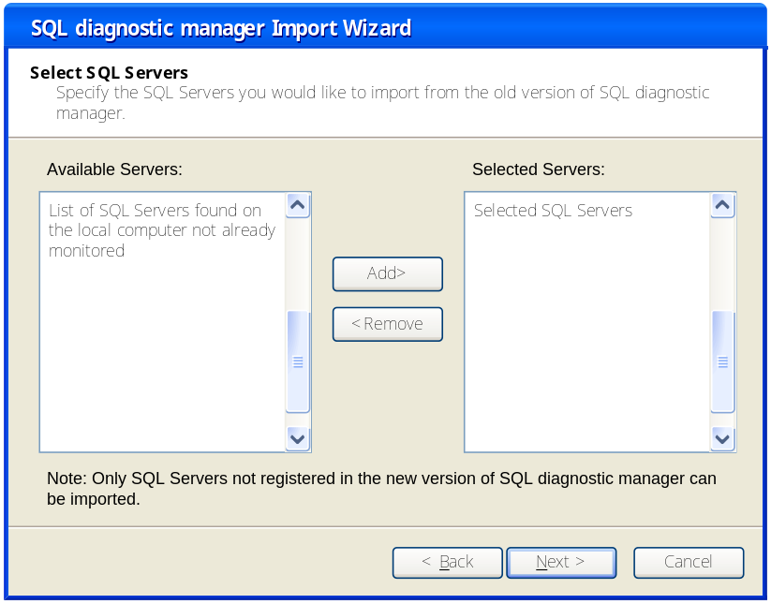

Select Import Date
The customer can select if they want to import servers and historical data or just import the servers. By default the “Load historical data from” date will be set back to 30 days. If the customer selects “Just import the servers, …”, then historical data will not be imported.

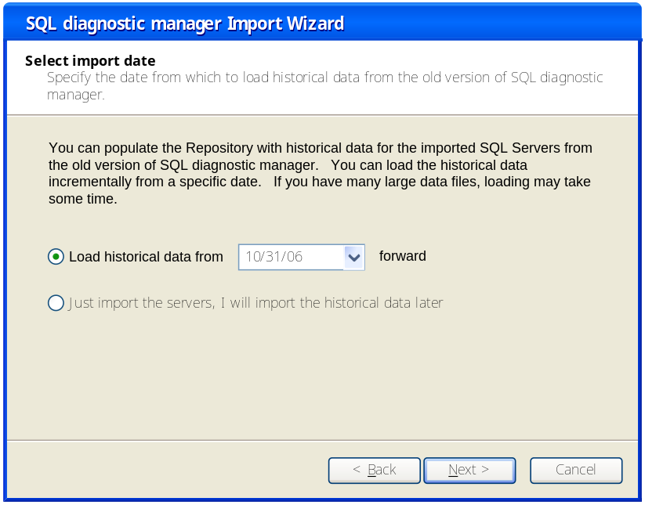

Settings Import Summary
This page shows which servers have been selected for import. The customer can use the Back button to make any corrections. When the Finish button is clicked the Wizard closes and the Import Status is displayed.
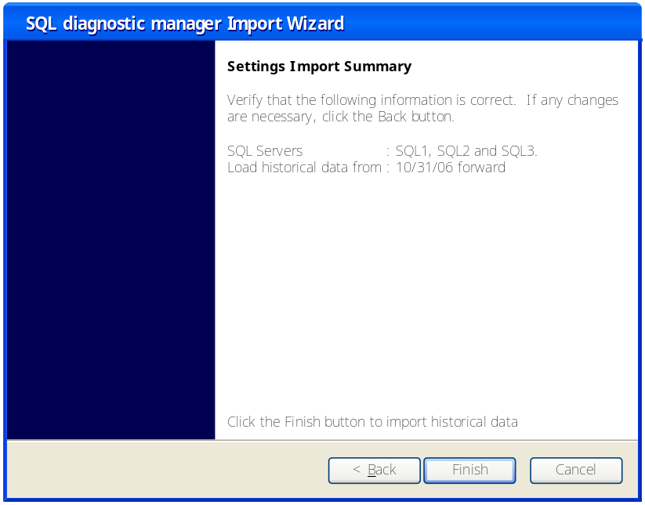

Import Status
The Import Status page displays the status and progress of the import operation. The Import Status text box displays the status of each import step.
The Overall Progress bar displays the overall import progress. This is calculated based on the settings import, and the days of historical data currently imported out of total number of days requested.
The customer can click on the Hide and Notify When Complete button. This will hide the Import Status page and create a notification icon on the system tray. The behavior will be similar to Windows Update icon.
The customer can click on the “Cancel Import” button, to cancel the import. Note that the cancel will not rollback import that has already taken place.

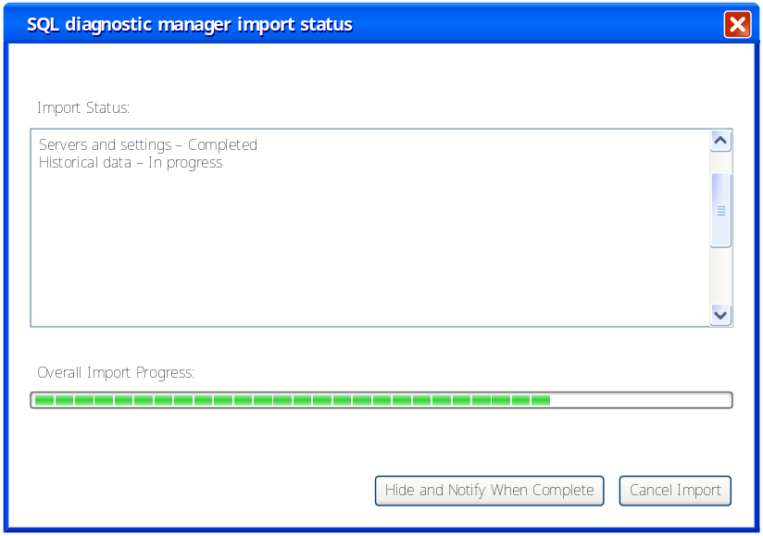

Import historical data

Select SQL Servers
This page is displayed when the user selects “Import historical data” option, on the “Choose Import Option” page. The Available Servers list box will contain those SQL Servers in DM 4.x that have been registered in DM 5.0. The Add/Remove buttons update the Selected Servers list box. When the Next button is clicked the “Select import date” page is shown.

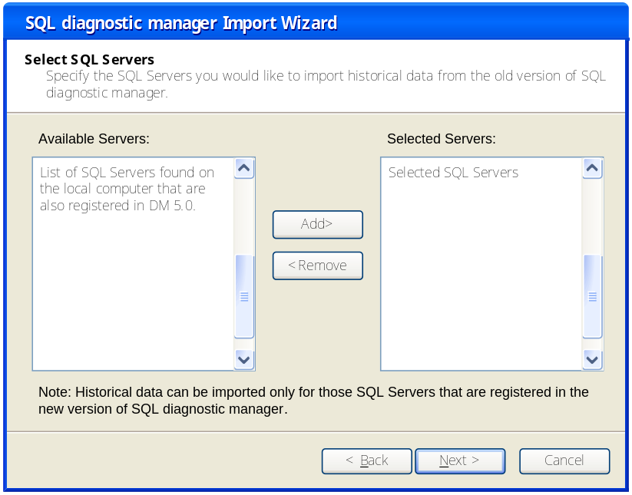

Select import date
The customer can enter the date from which to load the historical data incrementally. The grid shows the SQL Servers selected and the date to which the historical data has been imported. The “Load historical data from” field by default is set to 30 days back from the oldest import date. When the customer clicks the drop down, a calendar control is displayed which allows the customer to select a date.

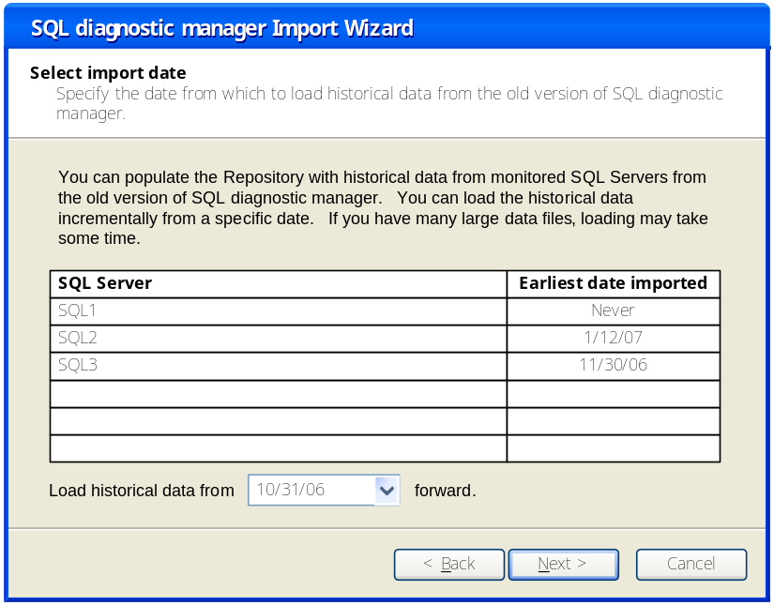

Historical Data Import Summary
The Settings Import Summary page will display which servers have been selected for import. The customer can use the Back button to make any corrections. When the Finish button is clicked the Wizard closes and the Import Status is displayed.
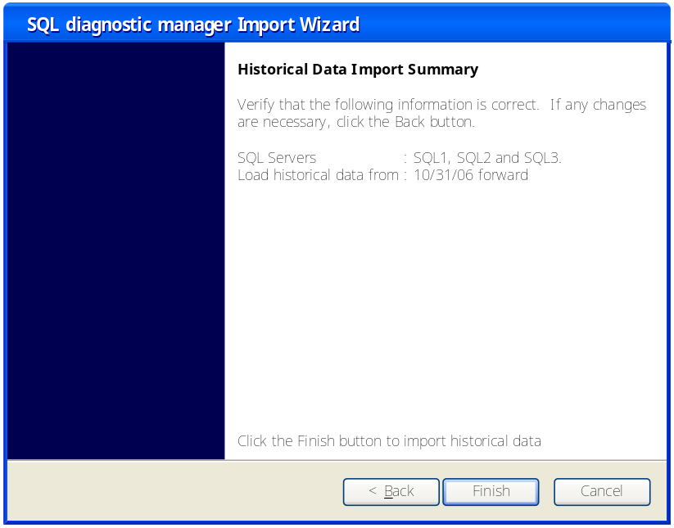

Import Status
See section 4.1.5.4 for details. Since only data is being imported the Import Status page will not have any references to settings import.

General User Interface Considerations
General user interface considerations will be listed in this section so they don’t have to be repeated in every section of the user interface portion of this specification.

Target Screen Resolution
Our target screen resolution is 1024x768. All main form, view and dialog designs will take this into consideration.

Localization
Since we have a number of foreign customers, installation of the desktop client on foreign operating systems will be supported. The following regional operating systems will be tested:
- English
- Spanish
- German
In addition, regional settings for numerical and date formats will be supported. These settings can be configured using the Windows Regional and Language Options dialog found in the Control Panel. We’ll rely on and test using these settings rather than include customization in our application.
Snapshots will be stored in the database including both the UTC and local time collected. The desktop client will provide options for choosing whether to display metrics based on the current regional time zone settings or based on the local time of the monitored SQL Server. These options can be configured via the Console Options dialog.
The following regional support WILL NOT be provided:
- Form and dialog text translation
- Right-to-left character sets
- Non-Gregorian calendars

Help Integration
At the very least, F1 help integration for each view, as well as main menu support will be available. Some other ideas for help integration have been provided in this specification, but the viability of those suggestions is yet to be determined.
TODO: Discuss help integration issues with Marlowe. This information may be included in a separate specification.

Installation and Upgrade
The Import Wizard will be installed along with the Desktop Client. There is no option for installing the Import Wizard by itself. The installer will create a shortcut in the Start menu for the Import Wizard. There are no upgrade issues for the Import Wizard.

Permissions and other Required Configuration
- Permission to read the DM 4.x settings and data on the local computer.
- Permissions to insert historical data into the Repository.

Licensing Issues
When the user clicks the Finish button on the Settings Import Summary page, the settings for all of the selected servers will be submitted to the SQLdm Management server. If the operation would cause the number of monitored servers to exceed the license limit, the Management server will return an error code to the Import Wizard, which will display an appropriate error message and allow the user to select fewer servers and try again. The operation will either completely succeed or completely fail. It won’t add a subset of the selected servers.

Dependencies

Dependencies on Idera Software
- SQLdm 5.0.

Third-Party Software Required on the Customer Machine
- .Net 2.0

Third-Party Software Required Internally

- Wizard Framework
- Infragistics

Technical Design

Architecture
An overview of the architecture behind this feature – how it works, components, communication between components etc

Settings Import

Bulk Submission
The SQLdm Management server will provide an interface through which the configuration settings for the specified servers can be submitted in bulk when the OK button is clicked. The operation will either succeed or completely fail. It will not add a subset of the selected servers.

Import Details
The following sections discuss the details of importing the various settings. In most cases, a screen shot from SQLdm 4.x is shown followed by a discussion on how the settings on that page will map to Project Houston.

Global Settings
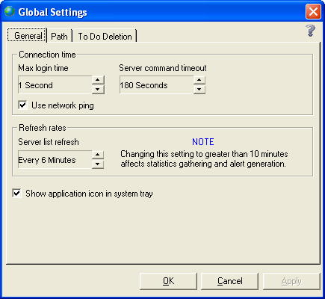
Except for the “Show application icon in system tray” checkbox, these settings will be imported. In 4.x, these settings are global. In Project Houston, they can be different for each monitored server. The Import Wizard will apply the same settings to every imported server.
The settings on the Path and To Do Deletion tabs are not imported.

Connection
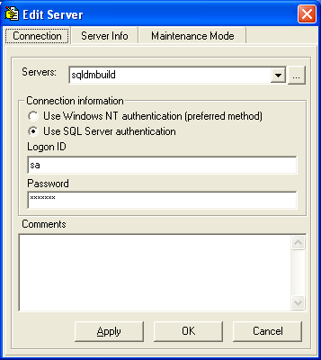
This information is always imported for each new server.

Server Information
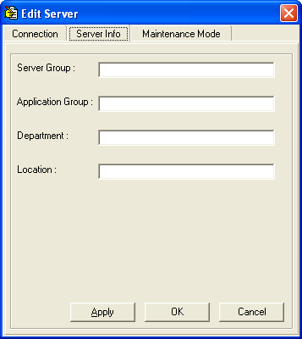
Only Department and Location will be imported.

Maintenance Mode
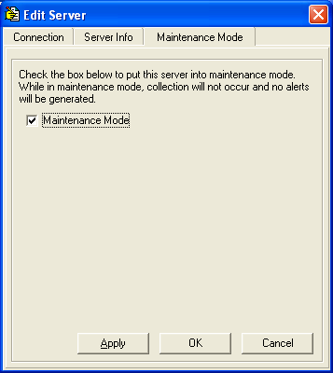
This setting is imported for each server.

Server Thresholds
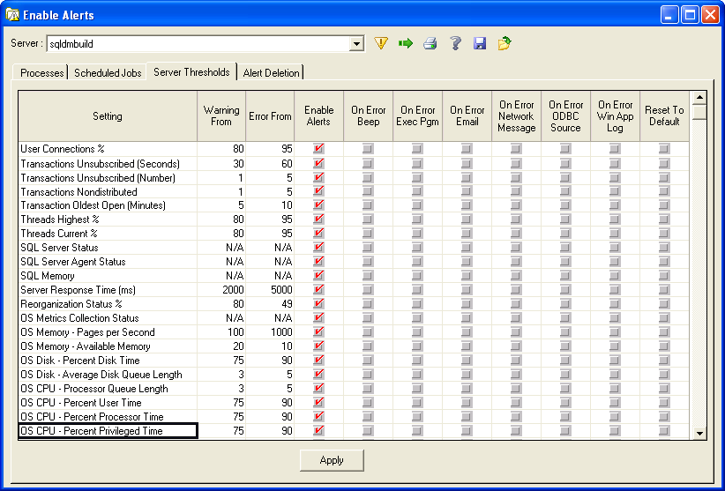

The Server Thresholds tab of the Enable Alerts dialog contains the majority of the alert threshold settings to be imported. Each of these has a corresponding metric in Project Houston.
There are two categories of metrics: scalar metrics and state metrics. Those with numeric values for the warning and error thresholds are scalar metrics and are straightforward to import. Those that contain N/A in the Warning and Error fields above are state metrics that have discrete state values.
For example the SQLdm 4.x UI provides the following description of the “SQL Server Status” metric: “Alert #1518 when SQL Server is started (from stopped or paused); Alert #1519 when stopped; Alert #1520 when paused; Alert #1522 when not accessible and alert #1523 when in any other condition.” In Project Houston, there will only be one alert and the alert state (stopped, paused, etc.) will be a property of the alert.
In 4.x, a check mark in the “On Error Email” column for the “SQL Server Status” metric means an email notification is generated when any of those states occur. In Project Houston, the user can designate each such state as a normal, warning, or critical alert. Therefore, this notification is imported into Project Houston by designating each state as critical to get the same behavior as 4.x. The other state metrics are handled in a similar fashion.
The “Enable Alerts” column is easily imported because Project Houston has the same concept of enabled/disabled alerts.
The “On Error Beep”, “On Error Exec Pgm”, “On Error Network Message”, and “On Error ODBC Source” columns are not imported into Project Houston because there is no corresponding functionality. Only the “On Error Email” and “On Error Win App Log” have corresponding notification providers in Project Houston, so these are imported.

Processes
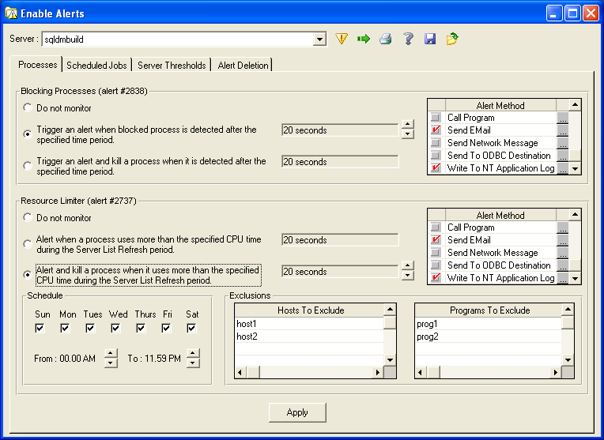
The Processes tab of the Enable Alerts dialog covers two alerts. These alerts have only one threshold (specified in seconds) in 4.x instead of the two thresholds most other alerts have (warning and critical/error). In Project Houston, these alerts will have two thresholds like all scalar alerts in order to reduce the number of special cases. When these are imported, the critical threshold will be set to whatever is specified on this dialog. The warning threshold will be set to 75% of that and disabled. If the email or event log notifications are enabled, they will be imported by creating notifications for the critical alerts. The other types of notifications are not supported in Project Houston.
The Schedule settings for the Resource Limiter alert will be applied to the notification rules that are generated for the alert in Project Houston. The Exclusions will apply to the alert.
The option to kill the process that triggers these alerts will not be supported in Project Houston. Future releases may provide generic support for actions taken in response to alerts.

Scheduled Jobs
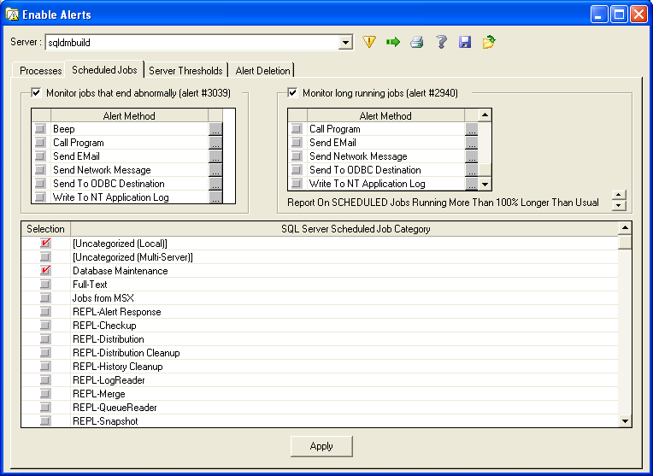
The first alert on this tab (jobs ending abnormally) falls into the state (vs. scalar) category of alerts. That is, either a job ended abnormally or not. Project Houston will support the exact same alert states so this alert configuration is imported as-is. The second alert (long running jobs) has only one threshold in 4.x (i.e. N% longer than usual). In Project Houston, this alert will have two thresholds (warning and critical) just like all other scalar alerts. When imported, the specified percentage will become the critical threshold and the warning threshold will be 75% of that. Notification rules will be generated for the critical alert.
The checkboxes in the lower pane will be applied to the alert just as they are in 4.x.

Email Notification Destinations
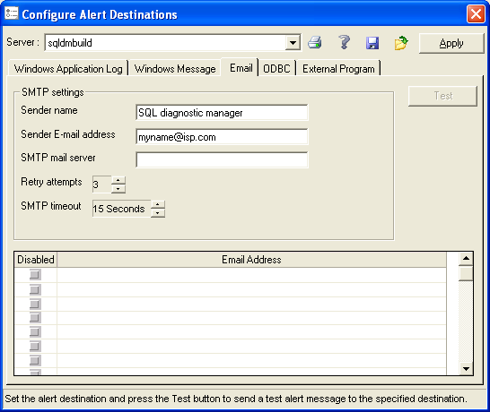
In 4.x, this information is specified for each SQL Server being monitored. The SMTP settings will be imported by creating a new SMTP provider for each unique SMTP mail server.
For each alert that has email notification enabled in 4.x, the Import Wizard will create a notification rule associated with the alert that specifies the SMTP provider and list of email recipients imported for the current SQL Server.

Event Log Notification Destinations
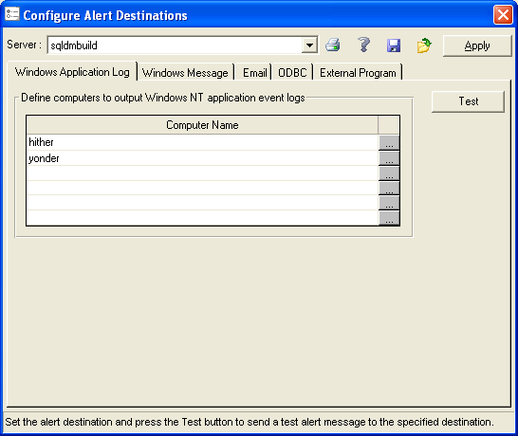
These settings are imported much like email recipients. For each alert that has event log notification enabled in 4.x, the import process will create a notification rule that specifies the list of computers imported for the current server. The user can then edit the rules to have a different list of computers per rule if required.

Query Monitor
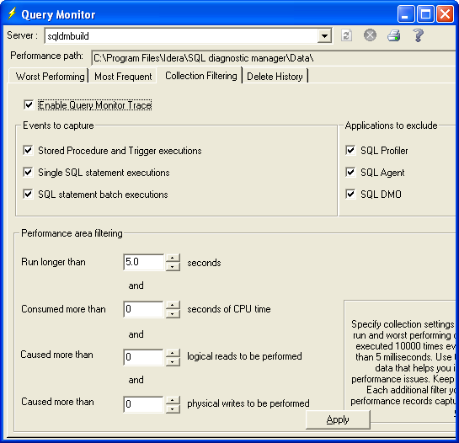
All of these settings will be imported except for “Performance path”, which is not applicable to Project Houston.

Table Growth and Reorganization Statistics
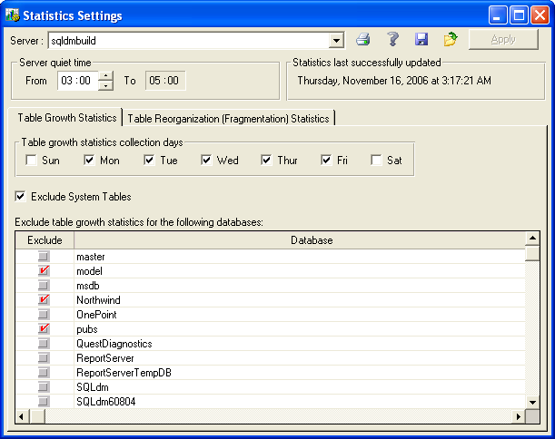
The Table Reorganization tab is exactly the same in Project Houston except it lacks the “Exclude System Tables” checkbox. Project Houston adds that checkbox to the Table Reorganization settings, so the Import Wizard will just copy the check state from the Table Growth Statistics tab.
Project Houston also adds the ability to enable and disable these statistics. The Import Wizard will enable the statistics.

Data Import

Installation Issues
Refer to the SQLdm Installation Specification for installation design and implementation details.

Schedule

Work Breakdown and Sizings
The target for completion of this feature is M7 (3/19/07). Note: The date may change because of M3 delay.
Component | Who | Sizing
R&D (learn the stats reader DLL usage, settings migration code, etc.) | Shekhar | 5 days
UI - Import Wizard layout and pages + Help | Shekhar
UI - Notification icon processing | Shekhar
Library  - DM 4.x  - List of monitored SQL Servers  - Retrieve settings  - Connection settings  - Alert thresholds  - Notification – e-mail recipients and event log.  - SMTP settings  - Maintenance mode settings  - Statistics collection settings  - Query monitor trace settings  - Retrieve data  - Server statistics  - OS metrics  - Database statistics  - Database/Table growth statistics  - Worst performing queries  - DM5  - Connecting  - Retrieve list of registered SQL Servers  - License checking  - Bulk import of settings  - Importing historical data to the Repository | Shekhar
DM 5 APIs needed  - Management service  - License count query  - Bulk insert of settings  - Unknowns (???)  - Database support  - Schema changes to store import state  - Unknowns (???) | Kurt/Vicky
Help | Marc
Install update | Mike White
Unit and Integration Testing | Shekhar
Total

Areas of Risk
There are many types of risks. For example, a section might describe
- Areas with big learning curve
- Design assumptions that still need to be proven
- a technical hurdle that needs to be overcome.
- An area which has many unknowns
- Outcomes of other plans/implementations which could affect the deliverability of this feature.
Where possible, each section should explain the risk, quantify the risk, enumerate possible actions to address the risk, and recommend the action that is appropriate.

Quality Assurance Considerations

Overview
Insert explanations for QA considerations that are not apparent from the rest of the specification. Include things like tests on platforms that you want run in greater width then a developer can easily do or which tests you would want as an acceptance test each time a release goes out the door.
This section should identify all the testing activity that should be performed to verify the project has:
- Satisfied the completion criteria
- Works consistently with the existing components or works at least as well as the component being replaced
- No other components have lost functionality or no longer work
- Meets the standards as defined and approved by this document
- Identifies all the edit rules for each data element in the process

Documentation Considerations

Bibliography
- Troubleshooting Performance Problems in SQL Server 2005
http://www.microsoft.com/technet/prodtechnol/sql/2005/tsprfprb.mspx

